Problem 4

1. Checking the stable condition with ul = 1. ur = 0.

The domain is [-5, 5]. Time is [0,1]. ul = 1. ur = 0.

Plotting x from [-1, 1], Time from [0,1].

|  |  |  |
| --- | --- | --- |
|  | 3D | X-T |
| Hx = 0.01  Ht = 0.005 | 2-1-3D | 2-1-x_t |
| Hx = 0.01  Ht = 0.01 | 2-2-3D | 2-2-x_t |
| Hx = 0.01  Ht = 0.02 | 2-3-3D | 2-3-x-t |

When the stable condition is violated (Hx = 0.01 Ht = 0.02), we cannot see shocks appearing (only red and blue colors in 3D plot). When the stable condition is valid, we can see shocks appearing (rainbow colors in 3D plot).

In x-t plot, we can conclude the shocking is traveling at v = 0.5 = 0.5\*(ul + ur).

Problem 4

1. Investigating the speed of shock.

The domain is [-5, 5]. Time is [0,1]. hx = 0.01. ht = 0.005.

Plotting x from [-1, 1], Time from [0,1].

|  |  |  |
| --- | --- | --- |
|  | 3D | X-T |
| ul = 2  ur = 0 | 2-4-3D | 2-4-x-t  v = 1 = 0.5\*(ul + ur). |
| ul = 1  ur = 0 | 2-1-3D | 2-1-x_t  v = 0.5 = 0.5\*(ul + ur). |
| ul = 0.5  ur = 0 | 2-5-3D | 2-5-x-t  v = 0.25 = 0.5\*(ul + ur). |

This shows v = 0.5\*(ul + ur).

Problem 4: Plots of all 3 different u0. T in [0,1] (u: Initial Condition; V: Speed of Shock)

|  |  |  |  |  |  |  |
| --- | --- | --- | --- | --- | --- | --- |
| u1=    V= | 0  1  0.5 | | (x<0)  (x>0) | | 2-1-3D  3D | 2-1-x_t  X-T |
|  | | | | | 2-1-u_x  U-X | 2-1-u_t  U-T |
| u2=  No | | 0  X  1 | | (x<0)  [0,1]  (x>1)  Shock | 1-a-3D  3D | 1-a-x_t  X-T |
| 1-a-u_x  U-X | 1-a-u_t  U-T |
| u3= | | 1  1-X  0 | | (x<0)  [0,1]  (x>1) | 1-b-3D  3D | 1-b-x_t  X-T (Inverse Fan) |
| 1-b-u_x  U-X | 1-b-u_t  U-T |
|  | |  | |  |  |  |

For u3 of Question 1(b), we plot another x-t picture until T=2:

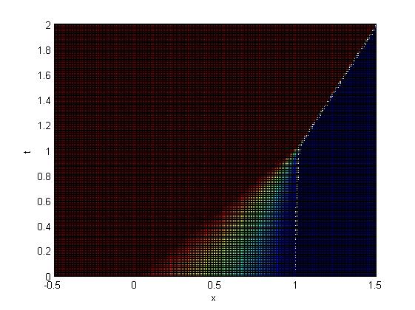

The shock appears at t=1, the speed is 0.5. The x-axis of shock (depending on time t) is x=0.5\*(t+1).